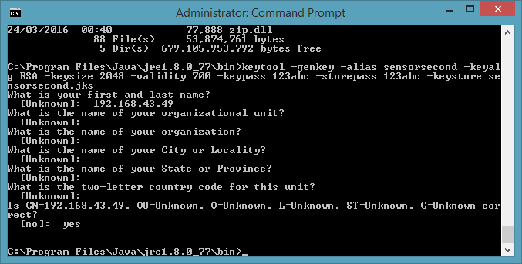

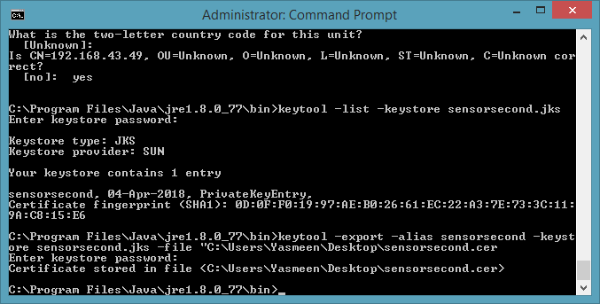

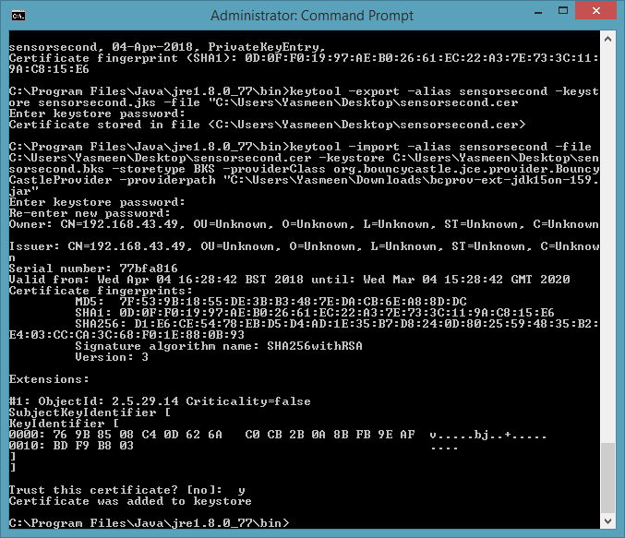

<https://www.amazon.co.uk/sourcingmap%C2%AE-Temperature-Sensor-Thermistors-MF52AT/dp/B00TGQ0MN4/ref=sr_1_3?ie=UTF8&qid=1523108255&sr=8-3&keywords=thermistor>

